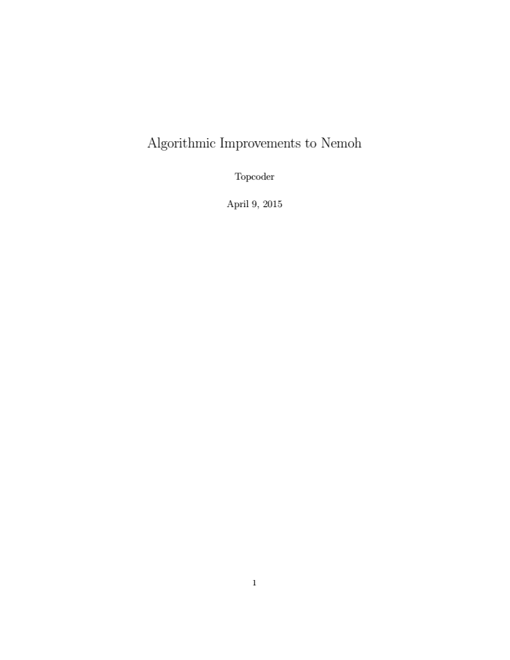

Algorithmic Improvements to Nemoh

Topcoder

April 9, 2015

1

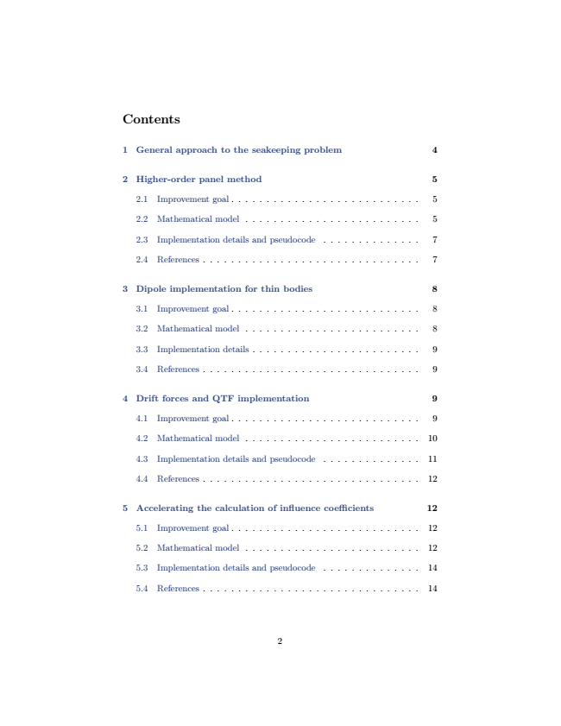

Contents

1 General approach to the seakeeping problem 4

2 Higher-order panel method 5

2.1 Improvement goal . . . . . . . . . . . . . . . . . . . . . . . . . . . 5

2.2 Mathematical model . . . . . . . . . . . . . . . . . . . . . . . . . 5

2.3 Implementation details and pseudocode . . . . . . . . . . . . . . 7

2.4 References . . . . . . . . . . . . . . . . . . . . . . . . . . . . . . . 7

3 Dipole implementation for thin bodies 8

3.1 Improvement goal . . . . . . . . . . . . . . . . . . . . . . . . . . . 8

3.2 Mathematical model . . . . . . . . . . . . . . . . . . . . . . . . . 8

3.3 Implementation details . . . . . . . . . . . . . . . . . . . . . . . . 9

3.4 References . . . . . . . . . . . . . . . . . . . . . . . . . . . . . . . 9

4 Drift forces and QTF implementation 9

4.1 Improvement goal . . . . . . . . . . . . . . . . . . . . . . . . . . . 9

4.2 Mathematical model . . . . . . . . . . . . . . . . . . . . . . . . . 10

4.3 Implementation details and pseudocode . . . . . . . . . . . . . . 11

4.4 References . . . . . . . . . . . . . . . . . . . . . . . . . . . . . . . 12

5 Accelerating the calculation of influence coefficients 12

5.1 Improvement goal . . . . . . . . . . . . . . . . . . . . . . . . . . . 12

5.2 Mathematical model . . . . . . . . . . . . . . . . . . . . . . . . . 12

5.3 Implementation details and pseudocode . . . . . . . . . . . . . . 14

5.4 References . . . . . . . . . . . . . . . . . . . . . . . . . . . . . . . 14

2

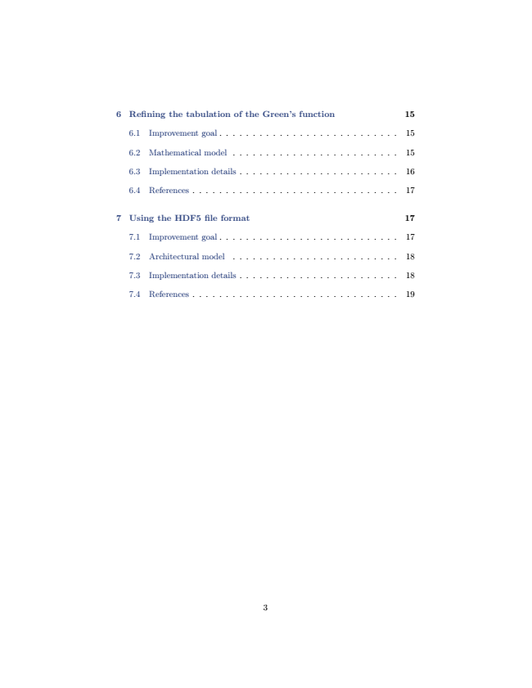

6 Refining the tabulation of the Green’s function 15

6.1 Improvement goal . . . . . . . . . . . . . . . . . . . . . . . . . . . 15

6.2 Mathematical model . . . . . . . . . . . . . . . . . . . . . . . . . 15

6.3 Implementation details . . . . . . . . . . . . . . . . . . . . . . . . 16

6.4 References . . . . . . . . . . . . . . . . . . . . . . . . . . . . . . . 17

7 Using the HDF5 file format 17

7.1 Improvement goal . . . . . . . . . . . . . . . . . . . . . . . . . . . 17

7.2 Architectural model . . . . . . . . . . . . . . . . . . . . . . . . . 18

7.3 Implementation details . . . . . . . . . . . . . . . . . . . . . . . . 18

7.4 References . . . . . . . . . . . . . . . . . . . . . . . . . . . . . . . 19

3

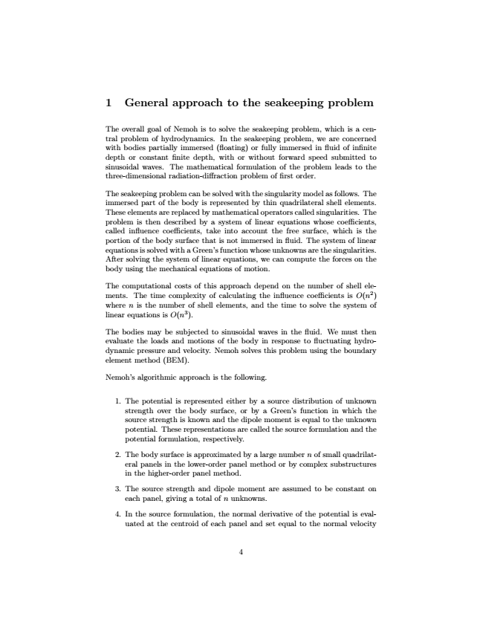

1 General approach to the seakeeping problem

The overall goal of Nemoh is to solve the seakeeping problem, which is a cen- tral problem of hydrodynamics. In the seakeeping problem, we are concerned with bodies partially immersed (floating) or fully immersed in fluid of infinite depth or constant finite depth, with or without forward speed submitted to sinusoidal waves. The mathematical formulation of the problem leads to the three-dimensional radiation-diffraction problem of first order.

The seakeeping problem can be solved with the singularity model as follows. The immersed part of the body is represented by thin quadrilateral shell elements. These elements are replaced by mathematical operators called singularities. The problem is then described by a system of linear equations whose coefficients, called influence coefficients, take into account the free surface, which is the portion of the body surface that is not immersed in fluid. The system of linear equations is solved with a Green’s function whose unknowns are the singularities. After solving the system of linear equations, we can compute the forces on the body using the mechanical equations of motion.

The computational costs of this approach depend on the number of shell ele- ments. The time complexity of calculating the influence coefficients is O(n2) where n is the number of shell elements, and the time to solve the system of linear equations is O(n3).

The bodies may be subjected to sinusoidal waves in the fluid. We must then evaluate the loads and motions of the body in response to fluctuating hydro- dynamic pressure and velocity. Nemoh solves this problem using the boundary element method (BEM).

Nemoh’s algorithmic approach is the following.

1. The potential is represented either by a source distribution of unknown strength over the body surface, or by a Green’s function in which the source strength is known and the dipole moment is equal to the unknown potential. These representations are called the source formulation and the potential formulation, respectively.

2. The body surface is approximated by a large number n of small quadrilat- eral panels in the lower-order panel method or by complex substructures in the higher-order panel method.

3. The source strength and dipole moment are assumed to be constant on

each panel, giving a total of n unknowns.

4. In the source formulation, the normal derivative of the potential is eval- uated at the centroid of each panel and set equal to the normal velocity

4

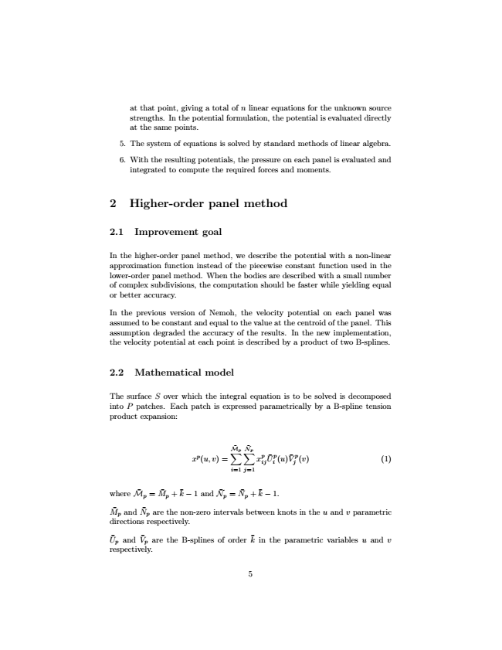

at that point, giving a total of n linear equations for the unknown source strengths. In the potential formulation, the potential is evaluated directly at the same points.

5. The system of equations is solved by standard methods of linear algebra.

6. With the resulting potentials, the pressure on each panel is evaluated and

integrated to compute the required forces and moments.

2 Higher-order panel method

2.1 Improvement goal

In the higher-order panel method, we describe the potential with a non-linear approximation function instead of the piecewise constant function used in the lower-order panel method. When the bodies are described with a small number of complex subdivisions, the computation should be faster while yielding equal or better accuracy.

In the previous version of Nemoh, the velocity potential on each panel was assumed to be constant and equal to the value at the centroid of the panel. This assumption degraded the accuracy of the results. In the new implementation, the velocity potential at each point is described by a product of two B-splines.

2.2 Mathematical model

The surface S over which the integral equation is to be solved is decomposed into P patches. Each patch is expressed parametrically by a B-spline tension product expansion:

xp(u, v) =

p∑ M ̄

i=1

p∑

N ̄

j=1

x

p ij

U ̄

i p

(u)

V ̄

j

p

(v) (1)

where

k ̄

− 1 and

k ̄

− 1.

M ̄

p

M ̄

p

=

M ̄

p

+

N ̄

p

=

N ̄

p

+

and

N ̄

p

are the non-zero intervals between knots in the u and v parametric directions respectively.

U ̄

p

and

V ̄

p

are the B-splines of order

k ̄

in the parametric variables u and v respectively.

5

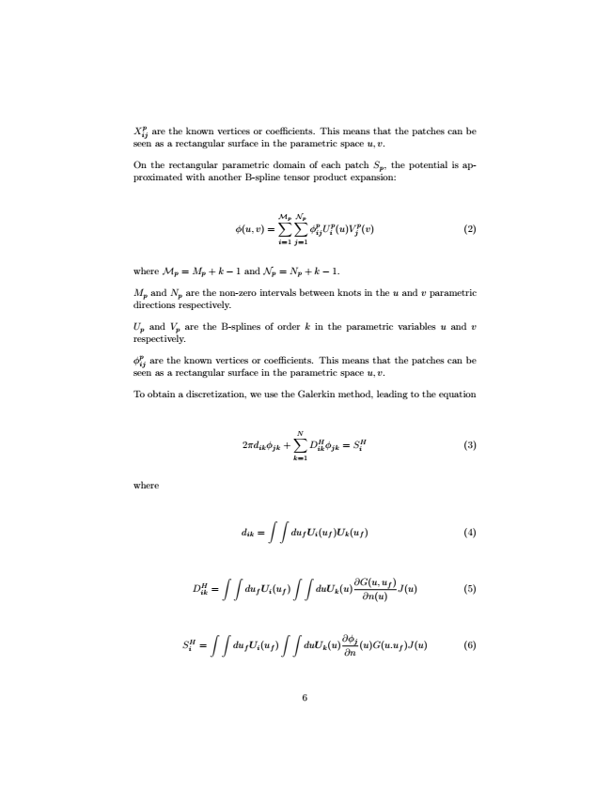

p X seen ij

are as a the rectangular known vertices surface or in coefficients. the parametric This space means u, that v.

the patches can be

On the rectangular parametric domain of each patch S

p

, the potential is ap- proximated with another B-spline tensor product expansion:

φ(u, v) =

p∑ M

p∑

N

i=1

j=1

p

p ij

i

j

p

(v) (2)

where M

p

φ

U

(u)V

+ k − 1.

M

p

= M

p

+ k − 1 and N

p

= N

p

are the non-zero intervals between knots in the u and v parametric directions respectively.

U

p

and N

p

are the B-splines of order k in the parametric variables u and v respectively.

φ

and V

p

p seen ij

are as the known vertices or coefficients. This means that a rectangular surface in the parametric space u, v.

the patches can be

To obtain a discretization, we use the Galerkin method, leading to the equation

2πd

ik

N∑

k=1

DH ik

= SH

i

(3)

where

d

ik

φ

jk

+

φ

jk

∫ ∫

du

f

) (4)

DH ik

=

U

i

(u

f

)U

k

(u

f

∫ ∫

∫ ∫ du

f

duU

k

∂G(u, ∂n(u) u

f

)

J(u) (5)

SH i

=

U

i

(u

f

)

(u)

∫ ∫ ∫ =

du

f

U

i

(u

f

)

∫

duU

k

(u)

∂φ ∂n j

(u)G(u.u

f

)J(u) (6)

6

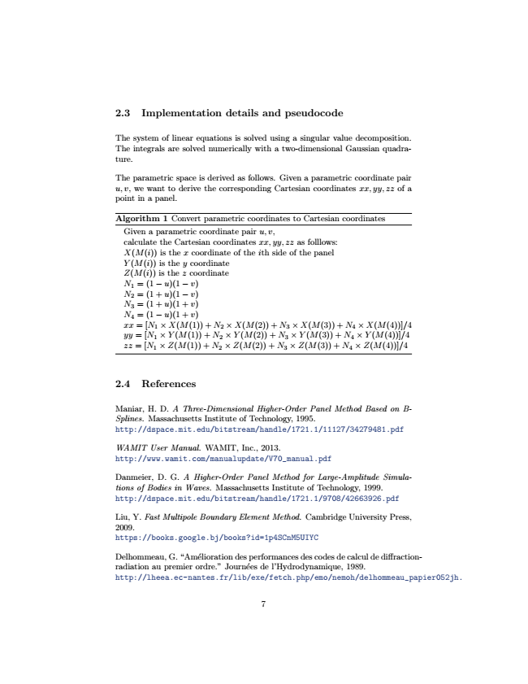

2.3 Implementation details and pseudocode

The system of linear equations is solved using a singular value decomposition. The integrals are solved numerically with a two-dimensional Gaussian quadra- ture.

The parametric space is derived as follows. Given a parametric coordinate pair u, v, we want to derive the corresponding Cartesian coordinates xx, yy, zz of a point in a panel.

Algorithm 1 Convert parametric coordinates to Cartesian coordinates

Given a parametric coordinate pair u, v, calculate the Cartesian coordinates xx, yy, zz as folllows: X(M(i)) is the x coordinate of the ith side of the panel Y (M(i)) is the y coordinate Z(M(i)) is the z coordinate N

1

= (1 − u)(1 − v) N

2

= (1 + u)(1 − v) N

3

= (1 + u)(1 + v) N

4

= (1 − u)(1 + v) xx = [N

1

× X(M(1)) + N

2

× X(M(2)) + N

3

× X(M(3)) + N

4

× X(M(4))]/4 yy = [N

1

× Y (M(1)) + N

2

× Y (M(2)) + N

3

× Y (M(3)) + N

4

× Y (M(4))]/4 zz = [N

1

× Z(M(1)) + N

2

× Z(M(2)) + N

3

× Z(M(3)) + N

4

× Z(M(4))]/4

2.4 References

Maniar, H. D. A Three-Dimensional Higher-Order Panel Method Based on B- Splines. Massachusetts Institute of Technology, 1995. http://dspace.mit.edu/bitstream/handle/1721.1/11127/34279481.pdf

WAMIT User Manual. WAMIT, Inc., 2013. http://www.wamit.com/manualupdate/V70_manual.pdf

Danmeier, D. G. A Higher-Order Panel Method for Large-Amplitude Simula- tions of Bodies in Waves. Massachusetts Institute of Technology, 1999. http://dspace.mit.edu/bitstream/handle/1721.1/9708/42663926.pdf

Liu, Y. Fast Multipole Boundary Element Method. Cambridge University Press, 2009. https://books.google.bj/books?id=1p4SCnM5UIYC

Delhommeau, G. “Amélioration des performances des codes de calcul de diffraction- radiation au premier ordre.” Journées de l’Hydrodynamique, 1989. http://lheea.ec-nantes.fr/lib/exe/fetch.php/emo/nemoh/delhommeau_papier052jh.

7

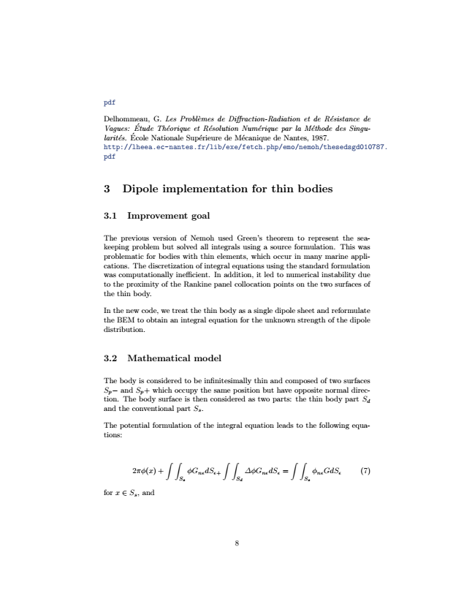

pdf

Delhommeau, Vagues: larités.

Ecole ́

Etude ́

G. Les Probl`emes de Diffraction-Radiation Théorique et Résolution Numérique Nationale Supérieure de Mécanique de et de Résistance de

par la Méthode Nantes, 1987.

des Singu-

http://lheea.ec-nantes.fr/lib/exe/fetch.php/emo/nemoh/thesedsgd010787. pdf

3 Dipole implementation for thin bodies

3.1 Improvement goal

The previous version of Nemoh used Green’s theorem to represent the sea- keeping problem but solved all integrals using a source formulation. This was problematic for bodies with thin elements, which occur in many marine appli- cations. The discretization of integral equations using the standard formulation was computationally inefficient. In addition, it led to numerical instability due to the proximity of the Rankine panel collocation points on the two surfaces of the thin body.

In the new code, we treat the thin body as a single dipole sheet and reformulate the BEM to obtain an integral equation for the unknown strength of the dipole distribution.

3.2 Mathematical model

The body is considered to be infinitesimally thin and composed of two surfaces S

p

− and S

p

+ which occupy the same position but have opposite normal direc- tion. The body surface is then considered as two parts: the thin body part S

d and the conventional part S

s

.

The potential formulation of the integral equation leads to the following equa- tions:

2πφ(x) +

∫ ∫

S

s

∫ ∫

S

d

∫ ∫ φG

nε

dS

ε+

∆φG

nε

dS

ε

=

φ

nε

GdS

ε

(7) S

s

for x ∈ S

s

, and

8

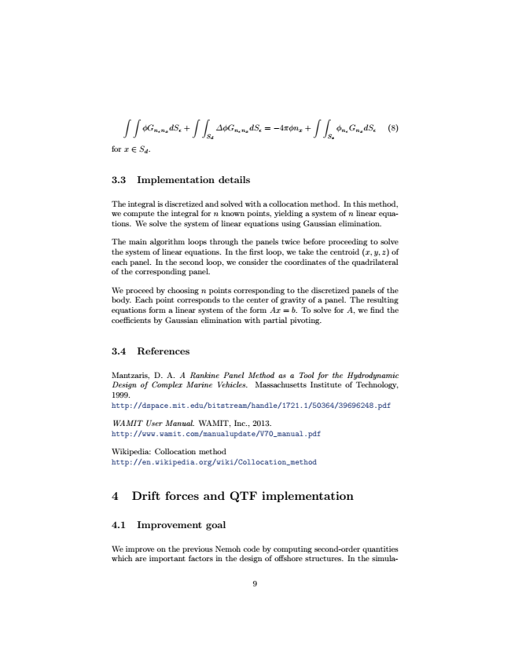

∫ ∫ ∫

∫ ∫

∫ φG

n

ε

dS

ε

+

S

d

∆φG

n

ε

dS

ε

= −4πφn

x

+

S

s

φ

n

ε

G

n

x

dS

ε

(8)

for x ∈ S

d

n

x

n

x

.

3.3 Implementation details

The integral is discretized and solved with a collocation method. In this method, we compute the integral for n known points, yielding a system of n linear equa- tions. We solve the system of linear equations using Gaussian elimination.

The main algorithm loops through the panels twice before proceeding to solve the system of linear equations. In the first loop, we take the centroid (x,y,z) of each panel. In the second loop, we consider the coordinates of the quadrilateral of the corresponding panel.

We proceed by choosing n points corresponding to the discretized panels of the body. Each point corresponds to the center of gravity of a panel. The resulting equations form a linear system of the form Ax = b. To solve for A, we find the coefficients by Gaussian elimination with partial pivoting.

3.4 References

Mantzaris, D. A. A Rankine Panel Method as a Tool for the Hydrodynamic Design of Complex Marine Vehicles. Massachusetts Institute of Technology, 1999. http://dspace.mit.edu/bitstream/handle/1721.1/50364/39696248.pdf

WAMIT User Manual. WAMIT, Inc., 2013. http://www.wamit.com/manualupdate/V70_manual.pdf

Wikipedia: Collocation method http://en.wikipedia.org/wiki/Collocation_method

4 Drift forces and QTF implementation

4.1 Improvement goal

We improve on the previous Nemoh code by computing second-order quantities which are important factors in the design of offshore structures. In the simula-

9

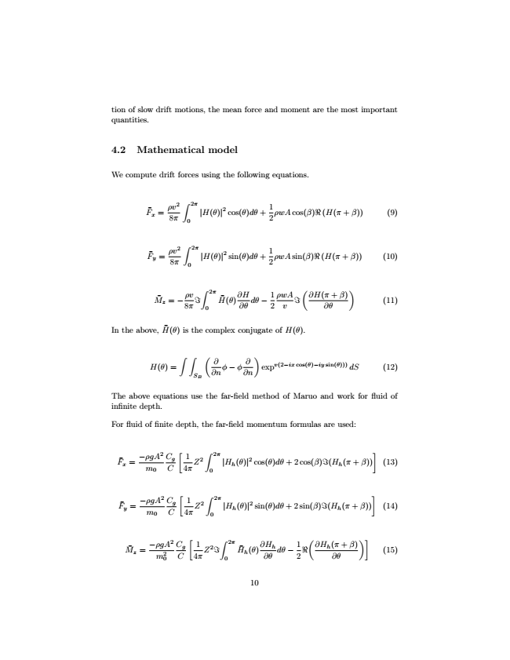

tion of slow drift motions, the mean force and moment are the most important quantities.

4.2 Mathematical model

We compute drift forces using the following equations.

F ̄

x

=

ρv2 8π

∫

0

2π

|H(θ)|

2

cos(θ)dθ +

1 2

ρwAcos(β) (H(π + β)) (9)

F ̄

y

=

ρv2 8π

∫

0

2π

|H(θ)|

2

sin(θ)dθ +

1 2

ρwAsin(β) (H(π + β)) (10)

M ̄

z

(

∂H(π + β) ∂θ

)

(11)

In the above,

ρv

∫

2π

8π

0 = −

H(θ)

̄

∂H ∂θ

dθ −

1 2

ρwA v

H(θ) ̄

is the complex conjugate of H(θ).

H(θ) =

(

∂ ∂n

)

expv(2−ix cos(θ)−iy sin(θ))) dS (12)

The above equations use the far-field method of Maruo and work for fluid of infinite depth.

For fluid of finite depth, the far-field momentum formulas are used:

F ̄

x

∫ ∫

S

B

φ − φ

∂n ∂

[

1 4π

]

(13)

F ̄

y

=

−ρgA2

m

0

C

g

∫

C

2π Z2

|H

h

(θ)|2 cos(θ)dθ + 2 cos(β) (H

h

(π + β)) 0

=

−ρgA2

m

0

[

1 4π

]

(14)

M ̄

z

C

g

∫

C

2π Z2

|H

h

(θ)|2 sin(θ)dθ + 2 sin(β) (H

h

(π + β)) 0

=

−ρgA2 m2 0

C

g

[

1 C

4π

Z2

∫

(

∂H

h

0

2π

H ̄

h

(θ)

∂H ∂θ

h

dθ −

1 2

)]

(15)

10

(π + β) ∂θ